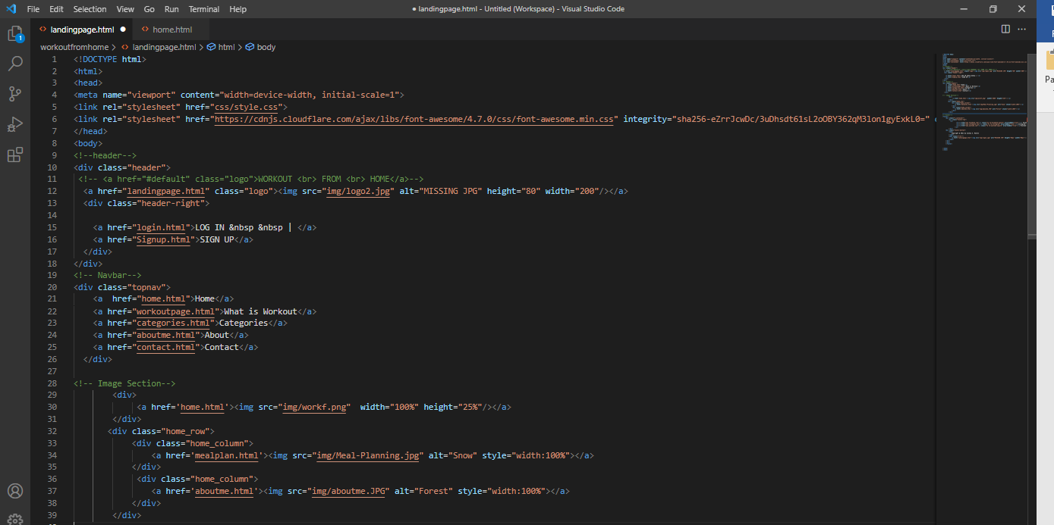Landing Page

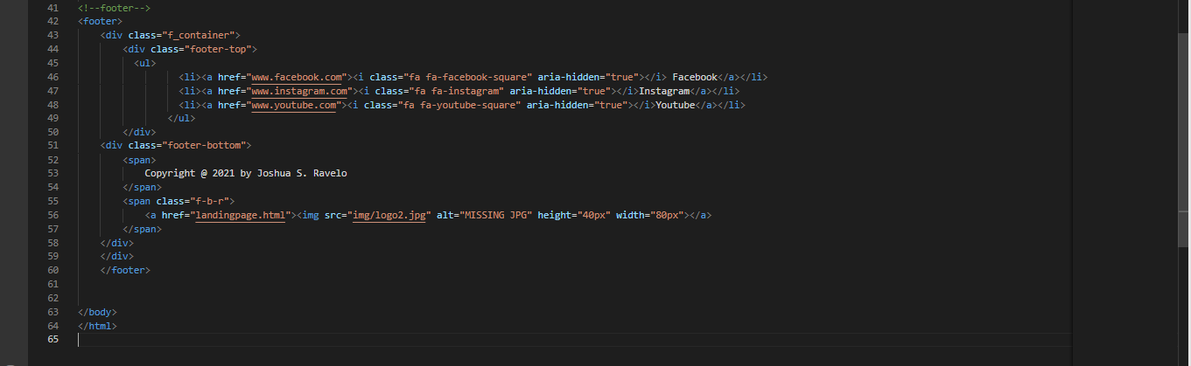

Home Page

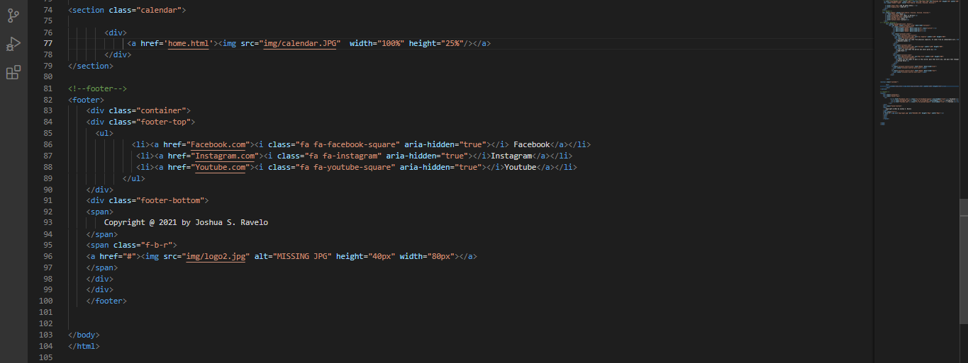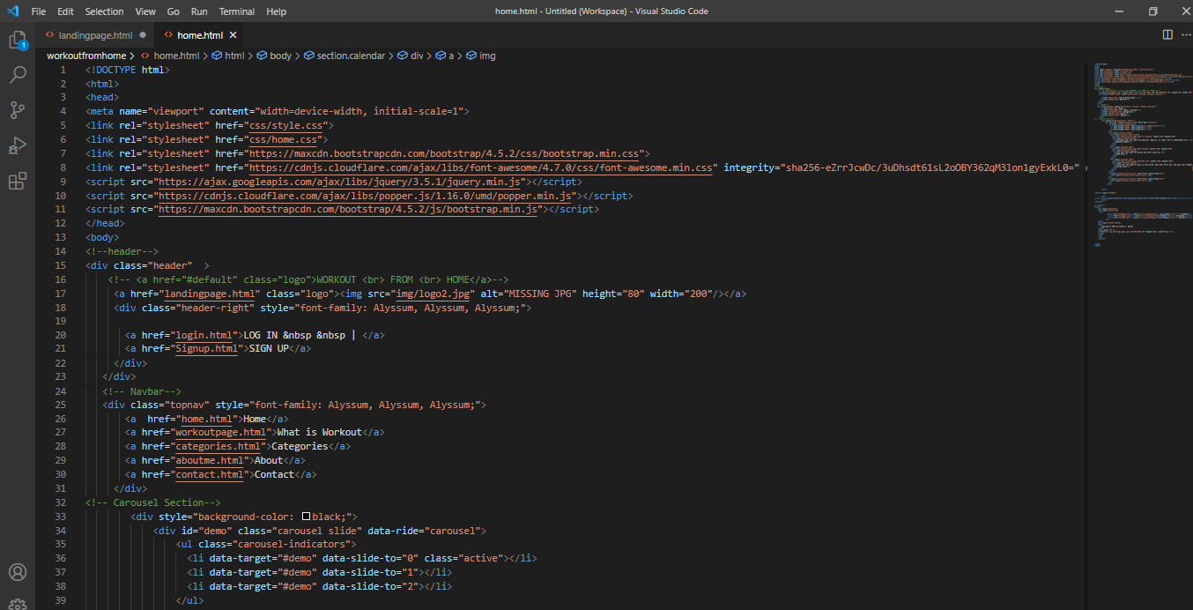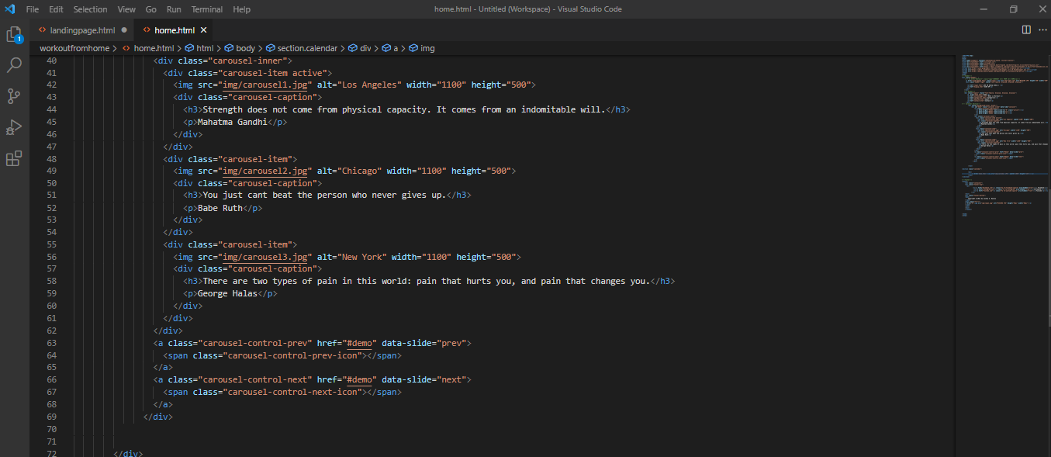

Login Page

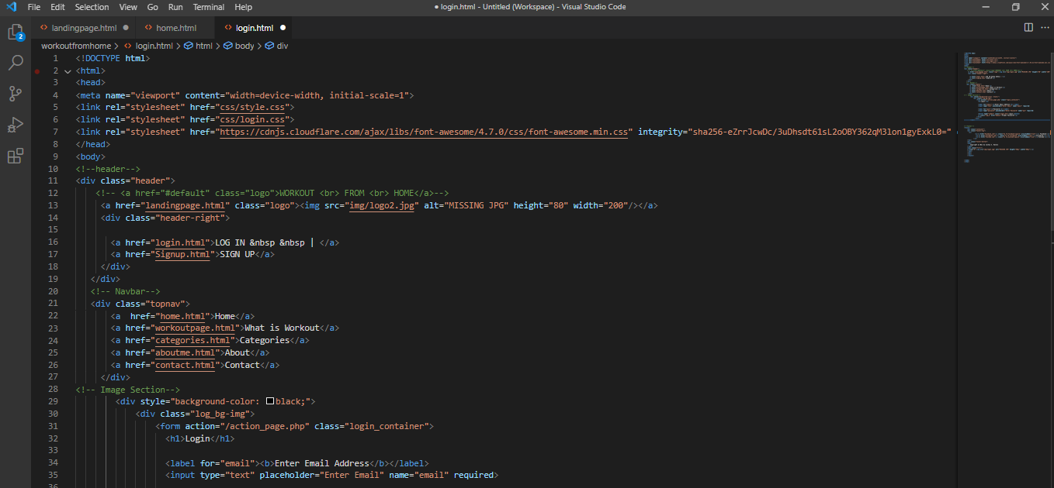

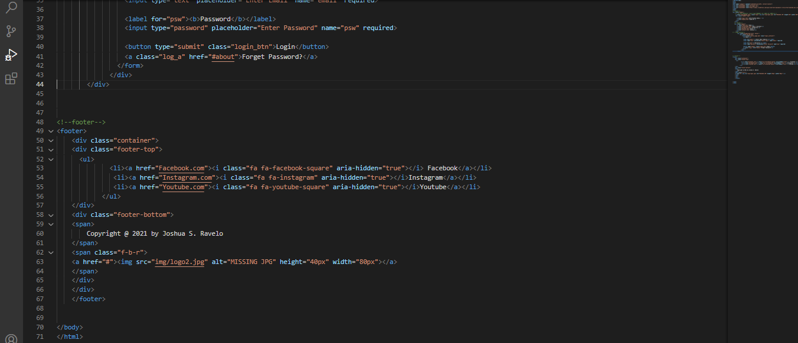

Sign up Page

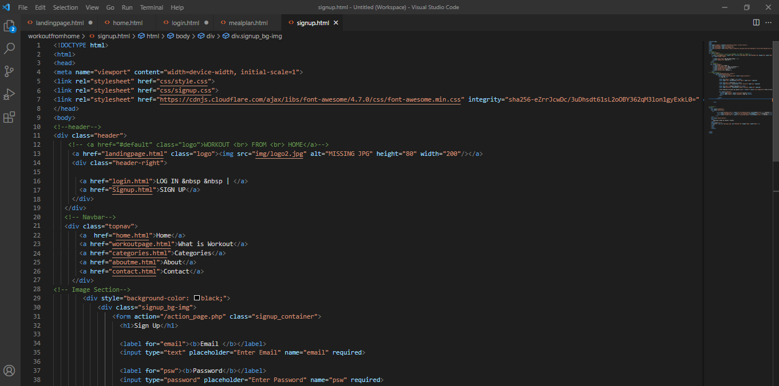

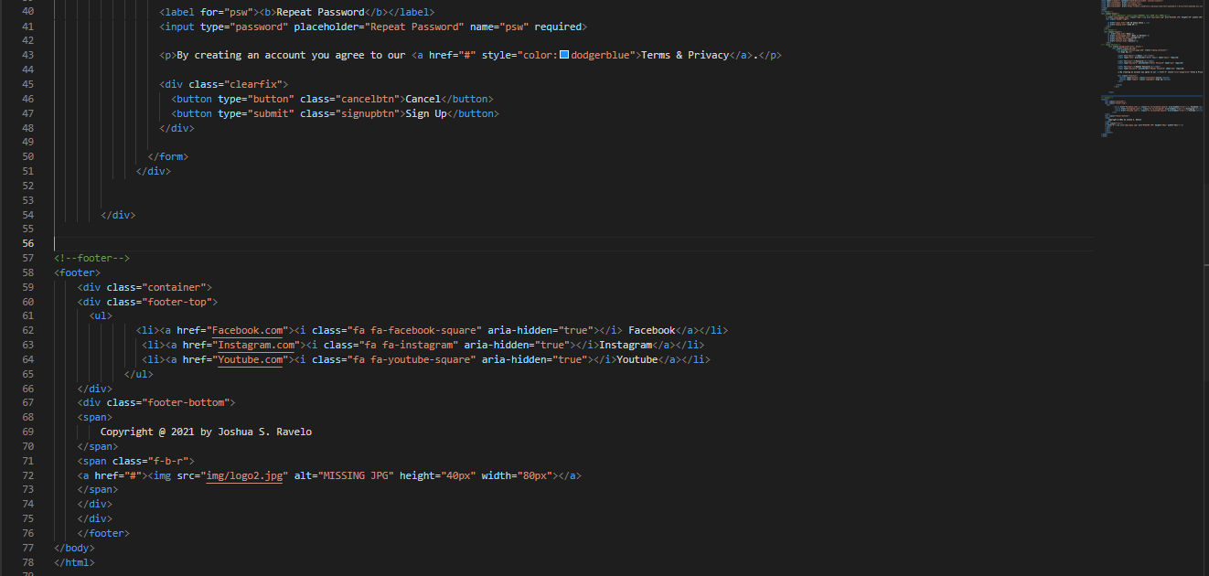

Categories Page

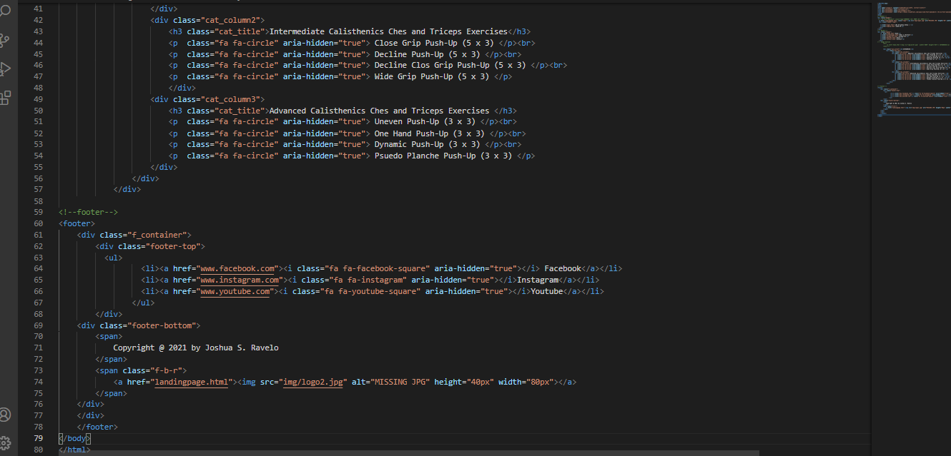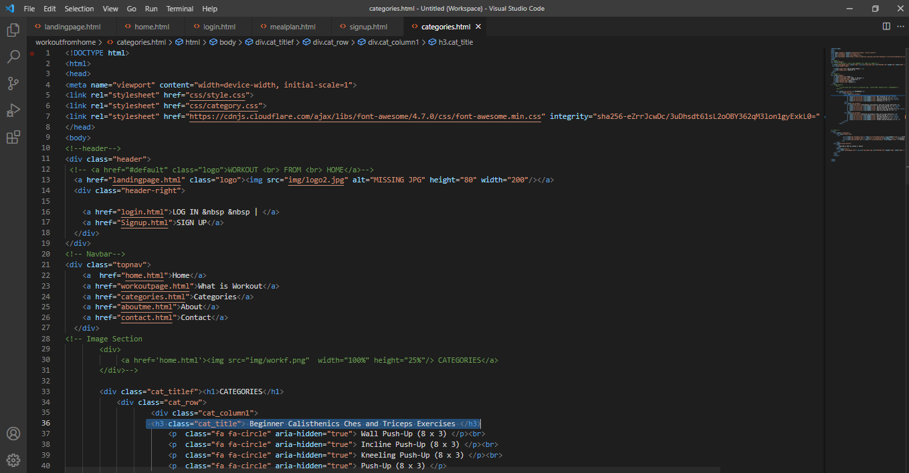

About Page

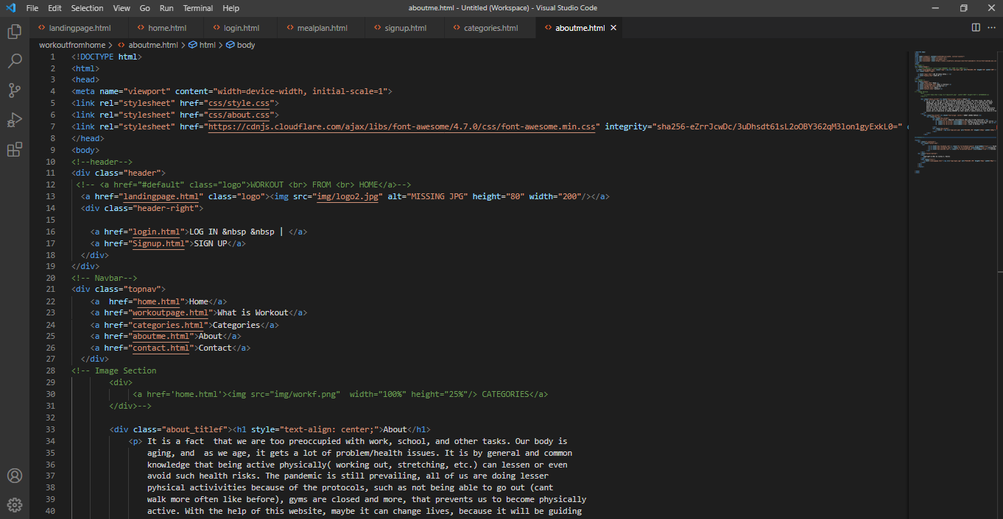

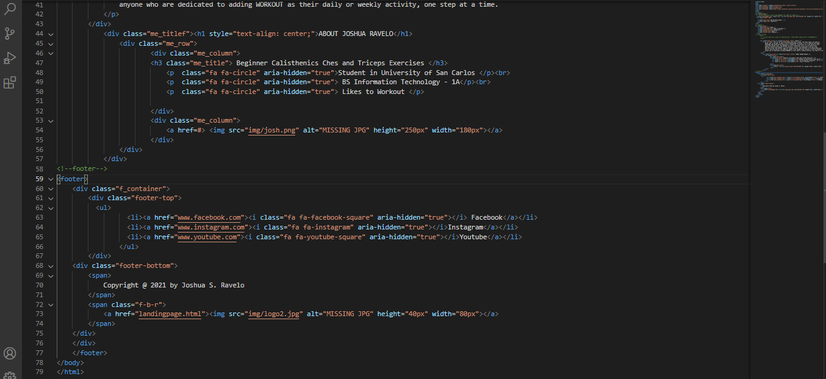

What is Workout Page

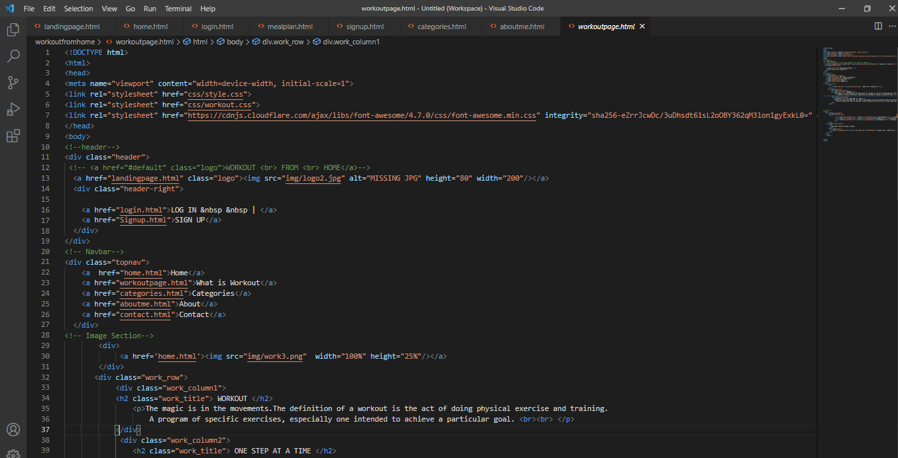

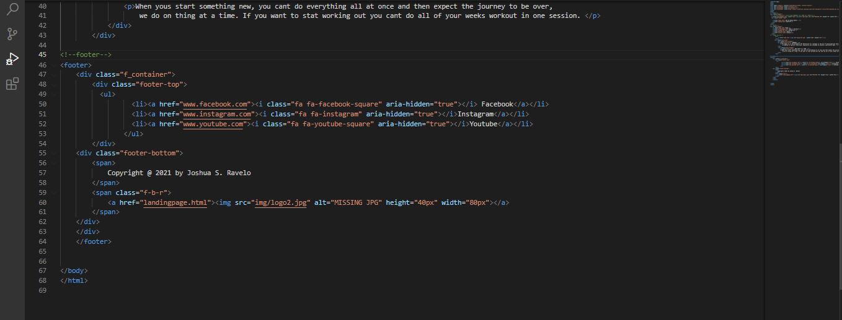

Contact Page

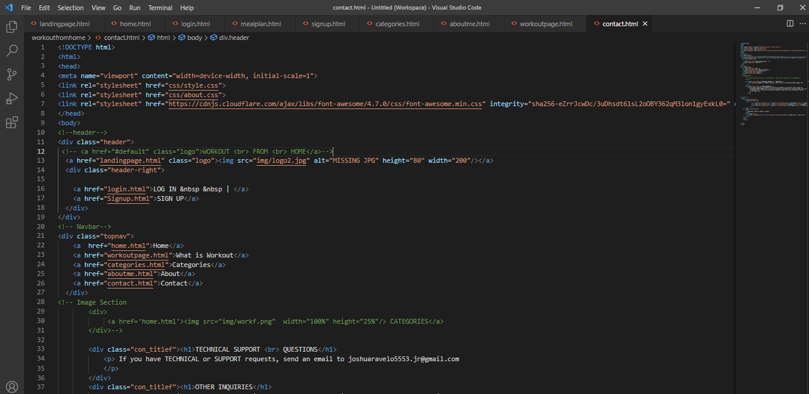

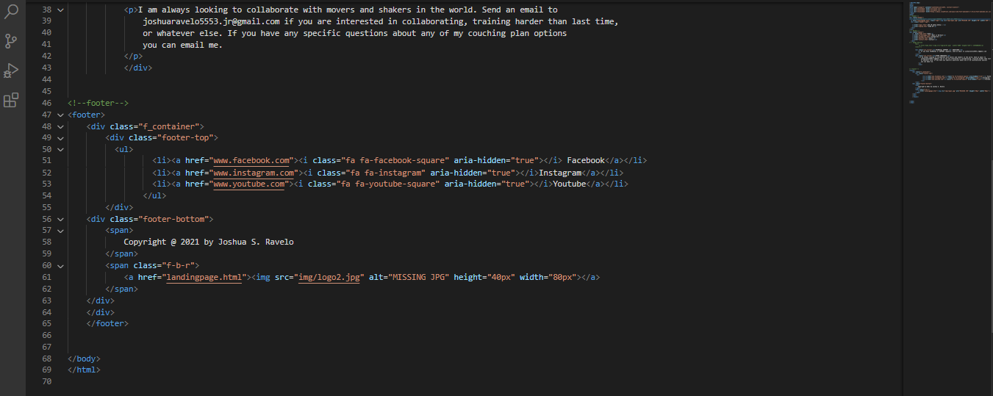

Meal Planner Page

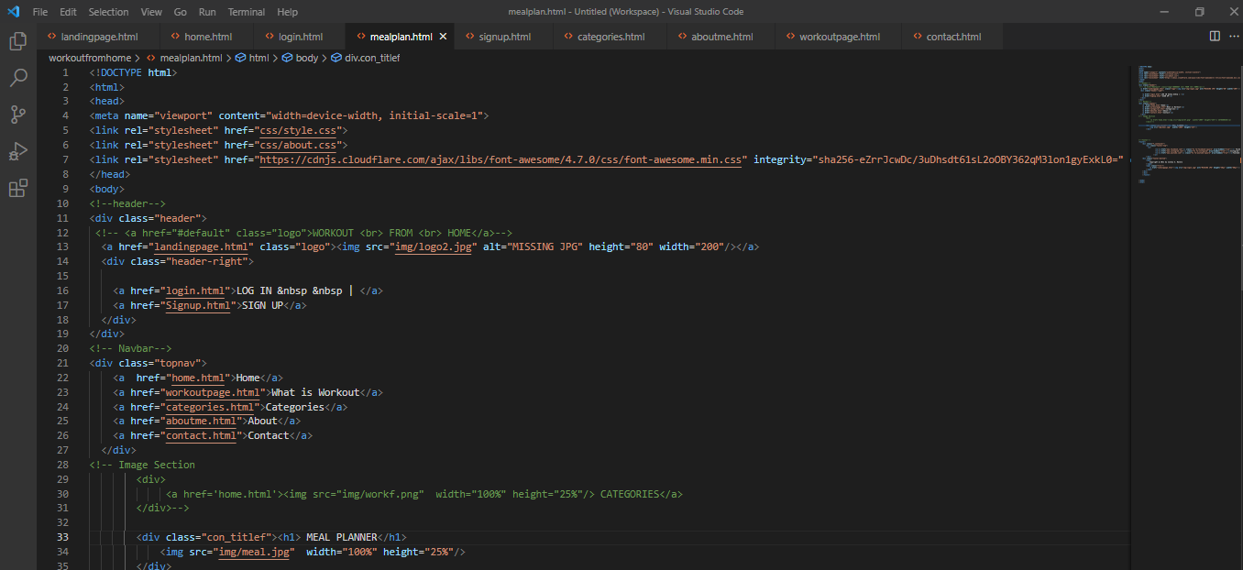

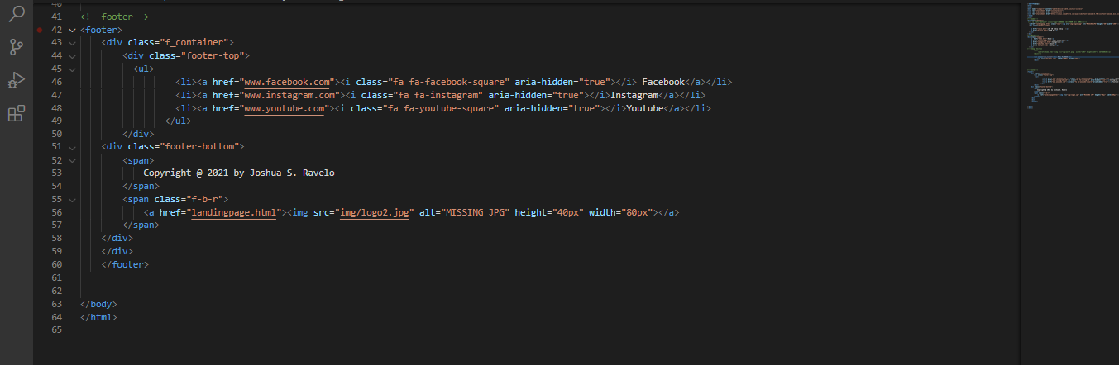

Stylesheet’s

Style.css

* {box-sizing: border-box;}

body {

  margin: 0;

  font-family: Alyssum, Alyssum, Alyssum;

  margin-left: 20px;

  margin-right: 20px;

}

.header {

  overflow: hidden;

  background-color: #f1f1f1;

  padding: 20px 10px;

}

.header a {

  float: left;

  color:#e2a165;

  text-align: center;

  padding: 12px;

  text-decoration: none;

  font-size: 18px;

  line-height: 25px;

  border-radius: 4px;

}

.header a.logo {

  font-size: 25px;

  font-weight: bold;

}

.header a:hover {

  background-color: #ddd;

  color: black;

}

.header a.active {

  background-color: dodgerblue;

  color: white;

}

.header-right {

  float: right;

}

@media screen and (max-width: 500px) {

  .header a {

    float: none;

    display: block;

    text-align: left;

  }

  .header-right {

    float: none;

  }

}

/* End Of Header*/

/* Navbar*/

  .topnav {

    overflow: hidden;

    background-color: #f1f1f1;

    border: 5px solid #e2a165;

    ;

  }

  .topnav a {

    float: left;

    color: black;

    text-align: center;

    padding: 14px 16px;

    text-decoration: none;

    font-size: 17px;

  }

  .topnav a:hover {

    background-color: #ddd;

    color: black;

  }

/* End of Navbar*/

/* Image SLanding Page */

.home_column {

    float: left;

    width:50%;

    padding: 5px;

  }

  /* Clearfix (clear floats) */

  .home_row::after {

    content: "";

    clear: both;

    display: table;

  }

/* End Image SLanding Page */

  /* Footer*/

footer {

    background:#e2a165;

    color:#fff;

    padding:15px 0px 15px 0px;

    width: 100%;

}

.footer-top {

  margin-bottom:15px;

  border-bottom:3px solid white;

  padding-bottom:15px;

}

.footer-top ul {

  padding:0;

  margin:0;

  margin-left:33.33%;

}

.footer-top li {

  list-style:none;

  display:inline-block;

  margin-right:100px;

  justify-content: center;

}

.footer-top a {

  color:white;

}

.footer-top a:hover {

     color:#e64946;

}

.f-b-r {

  float:right;

}

.f-b-r a {

     color:white;

    }

About.css

/* About Page */

.about_titlef{

    text-align: justify;

    background-color: black;

    border-style: solid;

    border-color: #f1f1f1;

    padding-bottom: 5px;

    padding-left: 50px;

    padding-right: 50px;

    font-family: Arial;

    color: #e2a165;

    font-size: 20px;

}

.me_column {

    float: left;

    width:50%;

    background-color: black;

    color:#e2a165;

    text-align: center;

    font-size: 20.1px;

    padding-bottom: 10px;

  }

  /* Clearfix (clear floats) */

  .home_row::after {

    content: "";

    clear: both;

    display: table;

    padding: 5px;

  }

.me_titlef{

    text-align: center;

    font-family: Arial;

    color: #e2a165;

    padding-bottom: 10px;

    padding-top: 10px;

    background-color: black;

}

/*End About Page */

.con_titlef{

    text-align: center;

    background-color: black;

    border-style: solid;

    border-color: #f1f1f1;

    padding-bottom: 5px;

    padding-left: 50px;

    padding-right: 50px;

    font-family: Arial;

    color: #e2a165;

    font-size: 20px;

}

Category.css

/* Paragraph Page */

.cat_title, .cat_titlef  {

    text-align: center;

 }

 .cat_titlef  {

    text-align: center;

    background-color:#e2a165;

    border-color: #f1f1f1;

    padding-bottom: 5px;

    padding-top: 5px;

 }

 .cat_column2

 {

    float: left;

    width:33.33%;

    padding: 10px;

    border-style: solid;

    border-color: #f1f1f1;

    background-color: #e2a165;

    font-size: 15px;

    color: black;

    font-family: Arial;

  }

 .cat_column1, .cat_column3 {

    float: left;

    width:33.33%;

    padding: 10px;

    border-style: solid;

    border-color: #f1f1f1;

    background-color: #000;

    font-size:15px;

    color: #e2a165;

    font-family: Arial;

  }

  .cat_row{

    text-align: left;

  }

  /* Clearfix (clear floats) */

  .cat_row::after {

    content: "";

    clear: both;

    display: table;

  }

/* End Image SLanding Page */

Home.css

 /* Make the image fully responsive */

 body {

    margin: 0;

    font-family: Alyssum, Alyssum, Alyssum;

    margin-left: 20px;

    margin-right: 20px;

  }

 .carousel-inner img {

    width: 100%;

    height: 100%;

  }

  .meal_title{

    color: #e2a165;

    background-color:black;

    display: center;

    text-align: center;

  }

Login.css

* {

    box-sizing: border-box;

    }

.log_bg-img {

    /* The image used */

    background-image: url("../img/homef.png");

    min-height: 380px;

    /* Center and scale the image nicely */

    background-position: center;

    background-repeat: no-repeat;

    background-size: cover;

    position: relative;

    width: 26%;

    margin-left: 35%;

  }

  /* Add styles to the form container */

  .login_container {

    position: absolute;

       margin: 20px;

    max-width: 300px;

    padding: 16px;

    color: black;

  }

  /* Full-width input fields */

  input[type=text], input[type=password] {

    width: 100%;

    padding: 15px;

    margin: 5px 0 22px 0;

    border: none;

  }

  input[type=text]:focus, input[type=password]:focus {

    background-color: #ddd;

    outline: none;

  }

  /* Set a style for the submit button */

  .login_btn {

    background-color: #e2a165;

    color: white;

    padding: 16px 20px;

    border: none;

    cursor: pointer;

    width: 100%;

    opacity: 0.9;

    font-family: Alyssum, Alyssum, Alyssum;

  }

  .login_btn:hover {

    opacity: 1;

  }

  .log_a:hover{

        color: #e2a165;

  }

Signup page

* {

    box-sizing: border-box;

    }

.signup_bg-img {

    /* The image used */

    background-image: url("../img/homef.png");

    min-height: 550px;

    /* Center and scale the image nicely */

    background-position: center;

    background-repeat: no-repeat;

    background-size: cover;

    position: relative;

    width: 40%;

    margin-left: 30%;

  }

  /* Add styles to the form container */

  .signup_container {

    position: absolute;

       margin: 20px;

    max-width: 300px;

    padding: 16px;

    color: black;

  }

  /* Full-width input fields */

  input[type=text], input[type=password] {

    width: 100%;

    padding: 15px;

    margin: 5px 0 22px 0;

    border: none;

  }

  input[type=text]:focus, input[type=password]:focus {

    background-color: #ddd;

    outline: none;

  }

  /* Set a style for all buttons */

button {

    background-color: #e2a165;

    color: #000;

    padding: 14px 20px;

    margin: 8px 0;

    border: none;

    cursor: pointer;

    width: 100%;

    opacity: 0.9;

    font-family: Alyssum, Alyssum, Alyssum;

  }

  button:hover {

    opacity:1;

  }

  /* Extra styles for the cancel button */

  .cancelbtn {

    padding: 14px 20px;

    background-color: #f1f1f1;

  }

  /* Float cancel and signup buttons and add an equal width */

  .cancelbtn, .signupbtn {

    float: left;

    width: 50%;

  }

Workouts.css

/* Paragraph Page */

.work_row{

    border-color: #f1f1f1;

    padding-bottom: 5px;

}

.work_title {

    text-align: center;

}

.work_column1 {

    float: left;

    width:50%;

    padding: 10px;

    border-color: gray;

    background-color: #e2a165;

    font-size: 20px;

    color: black;

    font-family: Arial;

  }

  .work_column2 {

    float: left;

    width:50%;

    padding: 10px;

    background-color: #000;

    font-size: 20px;

    color: #e2a165;

    font-family: Arial;

  }

  /* Clearfix (clear floats) */

  .work_row::after {

    content: "";

    clear: both;

    display: table;

  }

/* End Image SLanding Page */